Self Report of Accomplishments

1. Introduction

1.1 Title Slide


1.2 Getting Started
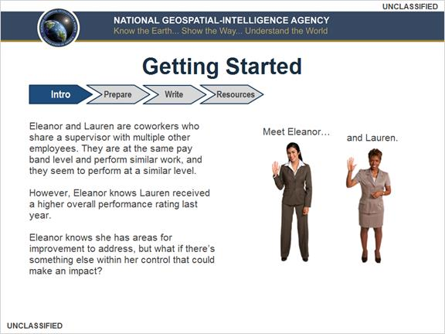

1.3 Getting Started
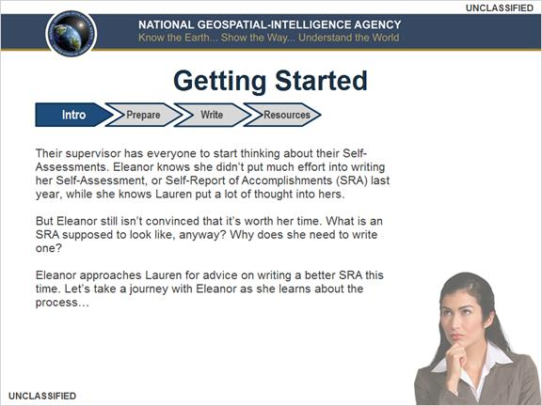

1.4 Course Objectives
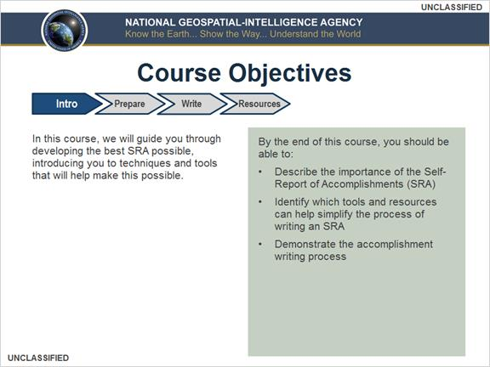

1.5 What is an SRA?
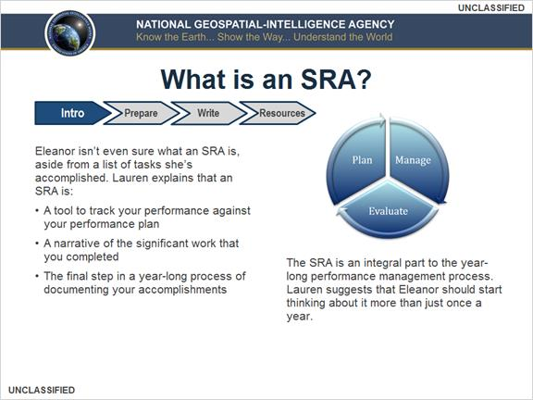

1.6 Why should I spend time writing a complete SRA? Select all that apply…
(Multiple Response, 10 points, 1 attempt permitted)
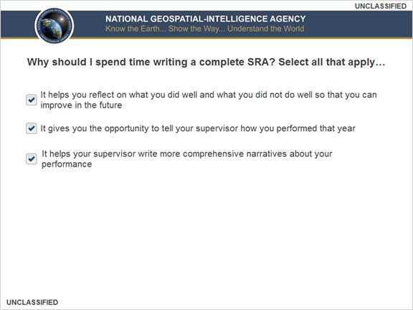
Correct | Choice
X | It helps you reflect on what you did well and what you did not do well so that you can improve in the future
X | It gives you the opportunity to tell your supervisor how you performed that year
X | It helps your supervisor write more comprehensive narratives about your performance
Feedback when correct:
That's right! You selected the correct response.

You should complete your SRA to reflect on what you did well and what you did not do well. Completing your SRA also gives you the opportunity to tell your supervisor how you performed that year, and, in turn, it helps your supervisor write more comprehensive narratives about you.
Feedback when incorrect:
You did not select the correct response.

You should complete your SRA to reflect on what you did well and what you did not do well. Completing your SRA also gives you the opportunity to tell your supervisor how you performed that year, and, in turn, it helps your supervisor write more comprehensive narratives about you.

Correct (Slide Layer)
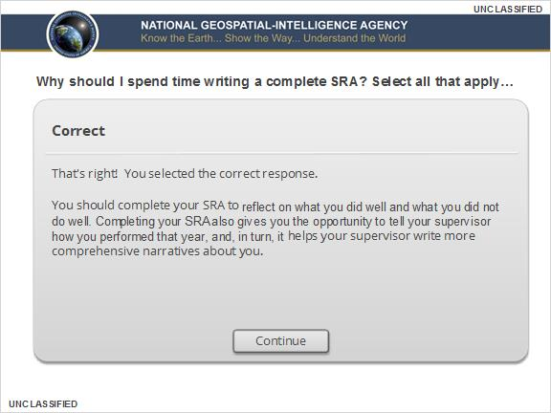

Incorrect (Slide Layer)
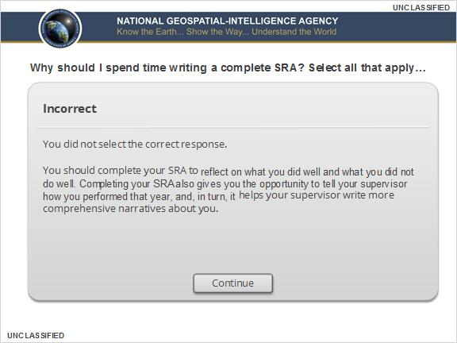

1.7 What Narratives Does My Supervisor Write About Me?
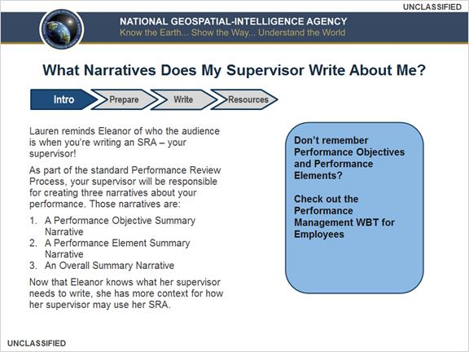

1.8 Eleanor’s Progress
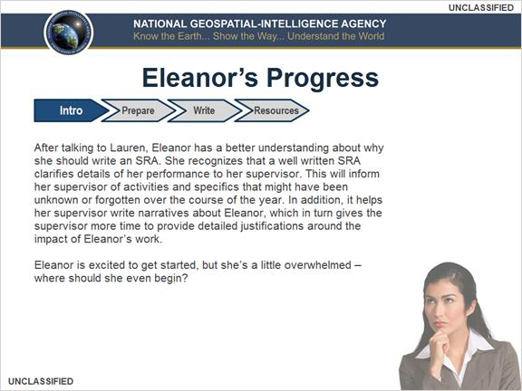

2. Prepare

2.1 What Should I Collect to Write My SRA?
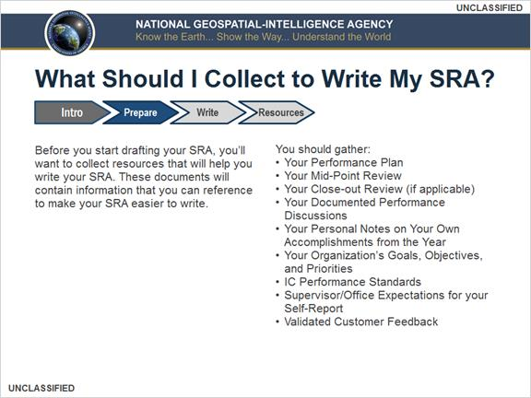

2.2 Where Can I Find This Information?
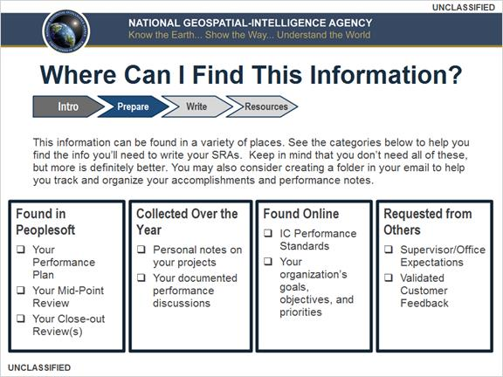

2.3 What Do I Need to Know Before I Write an SRA?
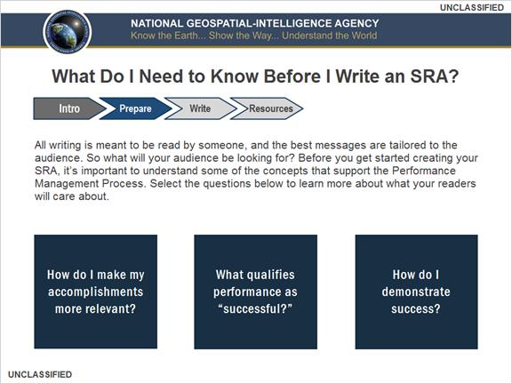

2.4 Linking Your Accomplishments to the Agency’s Mission
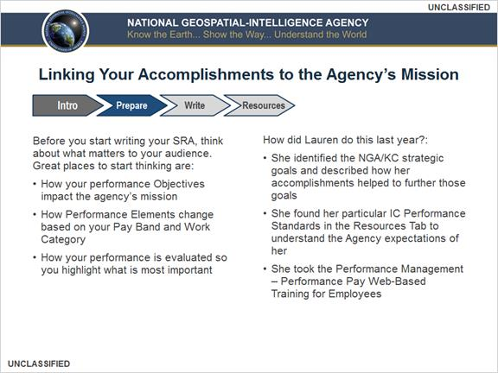

2.5 Performance Ratings
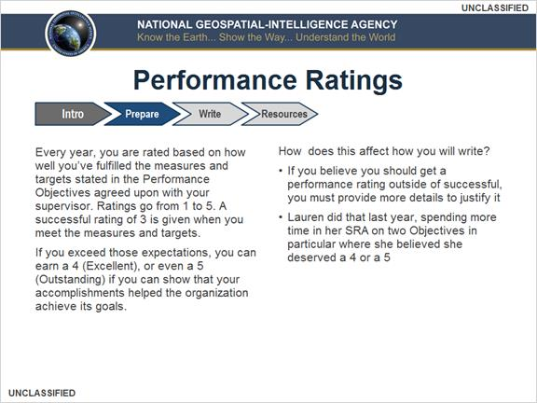

2.6 Measures and Targets
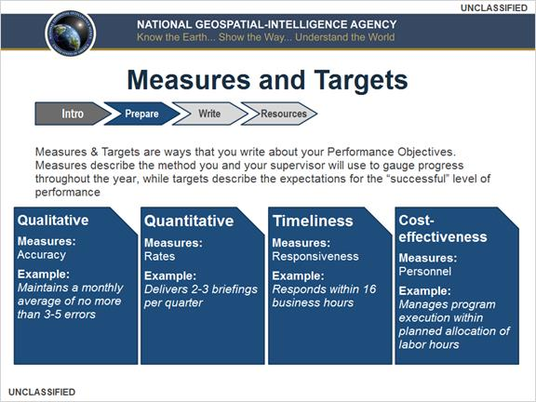

2.7 Exercise 1: Addressing Measures & Targets
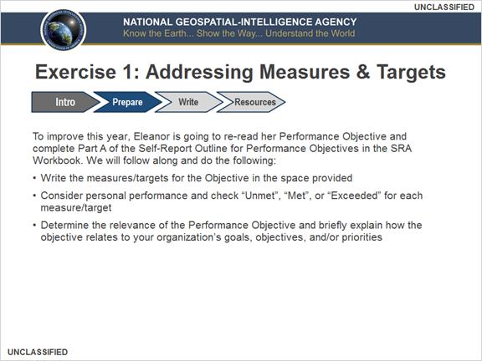

2.8 Exercise 1: Addressing Measures & Targets
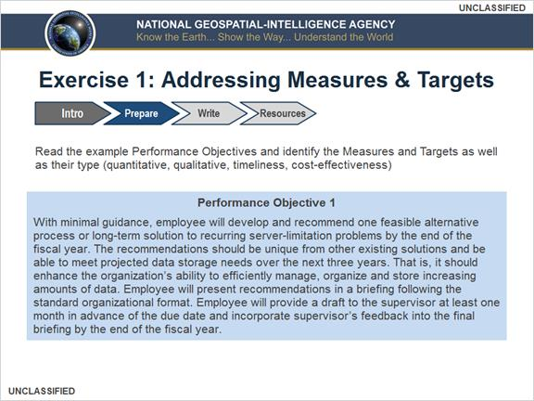

2.9 Exercise 1: Addressing Measures & Targets
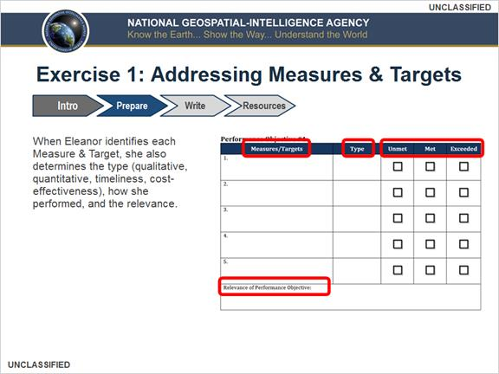

2.10 Exercise 1: Addressing Measures & Targets
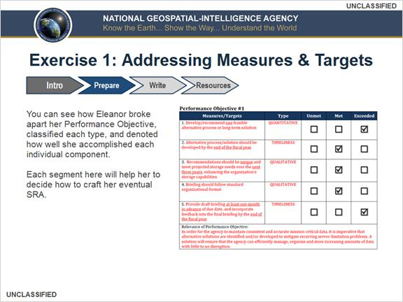

2.11 Exercise 1: Addressing Measures & Targets
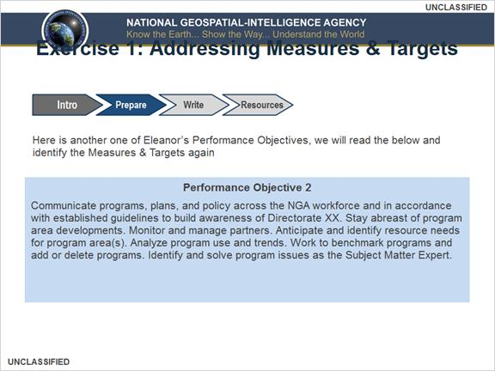

2.12 Exercise 1: Addressing Measures & Targets
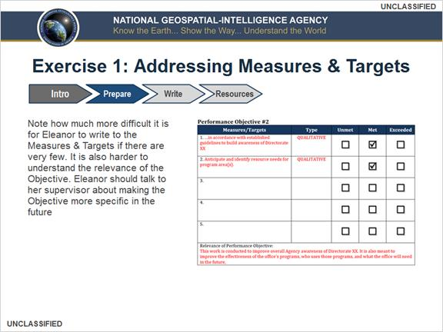

2.13 Exercise 1: Addressing Measures and Targets
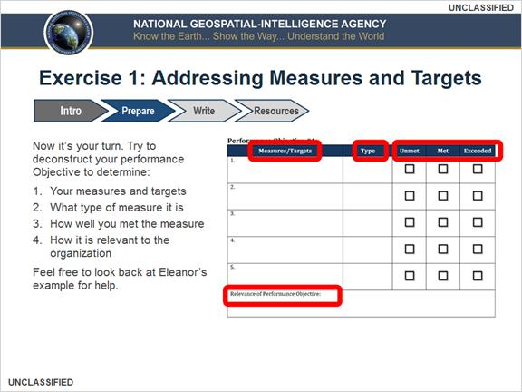

3. Write

3.1 Highlighting Accomplishments
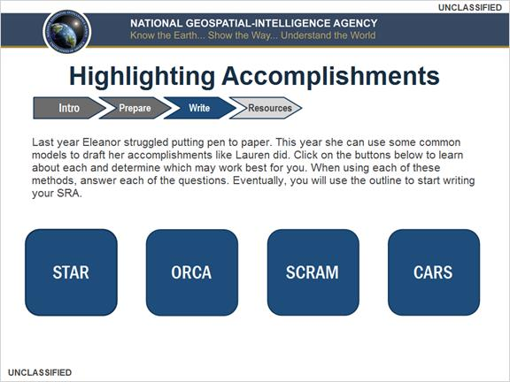

3.2 Self-Reporting Writing Models: STAR Model
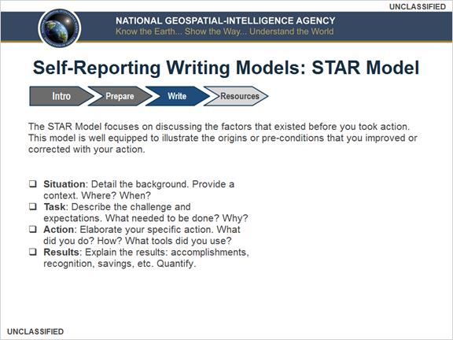

3.3 Self-Reporting Writing Models: ORCA Model
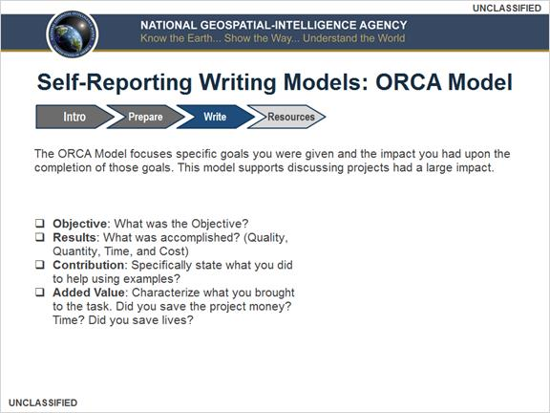

3.4 Self-Reporting Writing Models: SCRAM Model
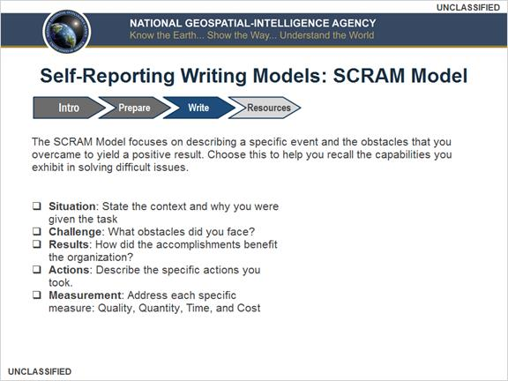

3.5 Self-Reporting Writing Models: CARS Model
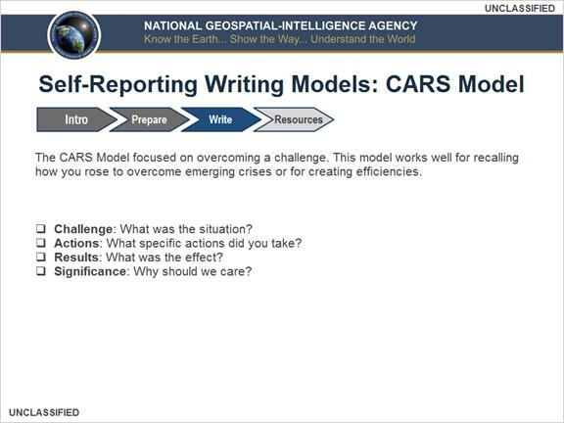

3.6 Choosing a Model
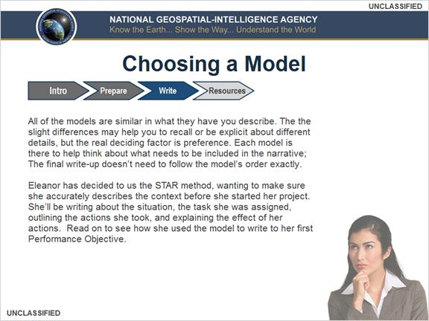

3.7 Using the STAR Method
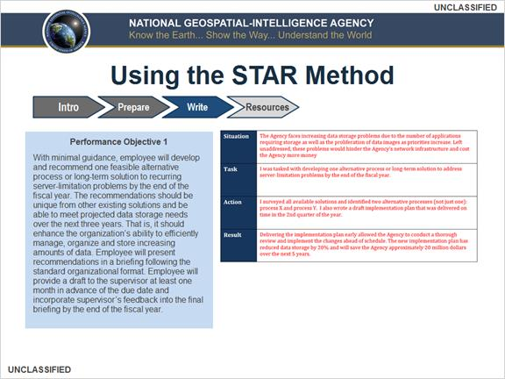

3.8 Understanding Performance Elements
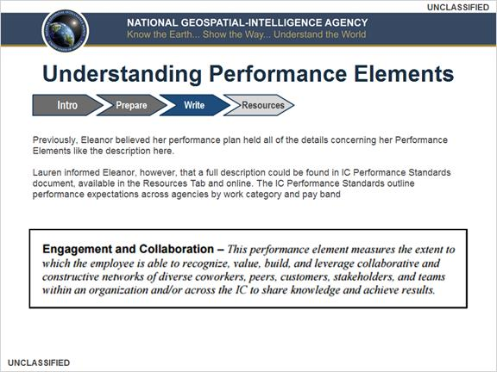

3.9 Addressing Performance Elements
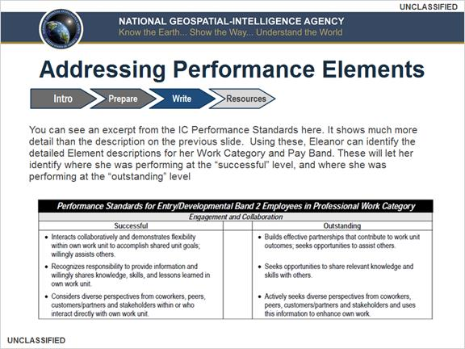

3.10 Understanding Performance Elements
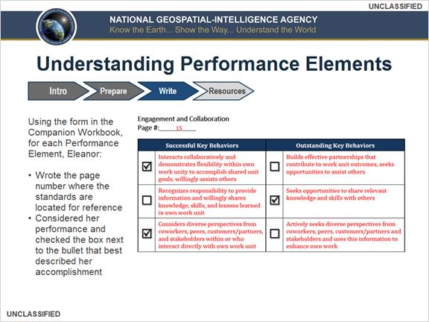

3.11 Highlighting Accomplishments
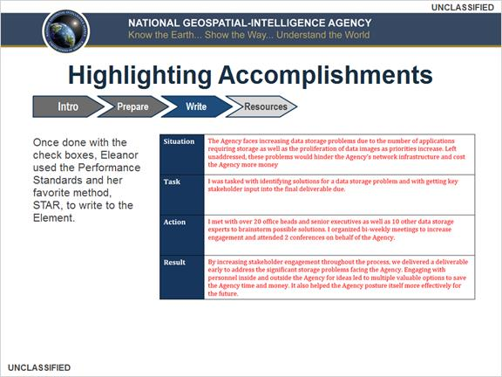

3.12 How Do I Organize My SRA?
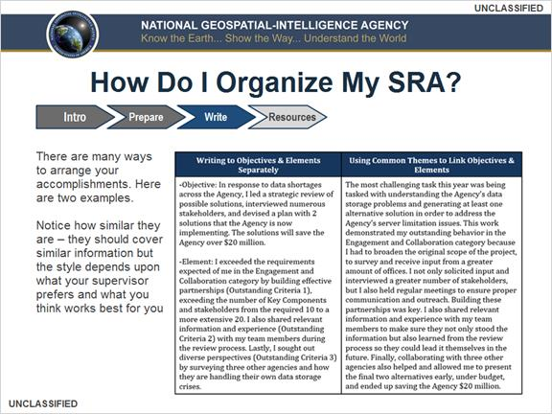

3.13 Going Forward
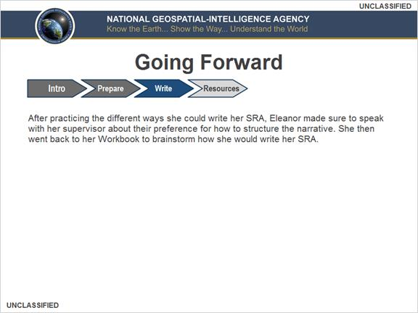

3.14 Final Tips Part 1
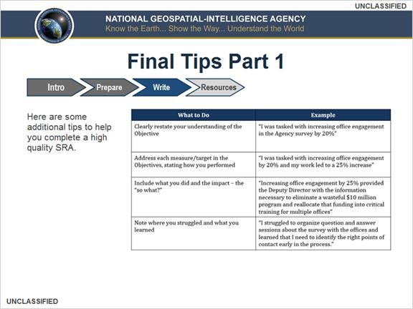

3.15 Final Tips Part 2
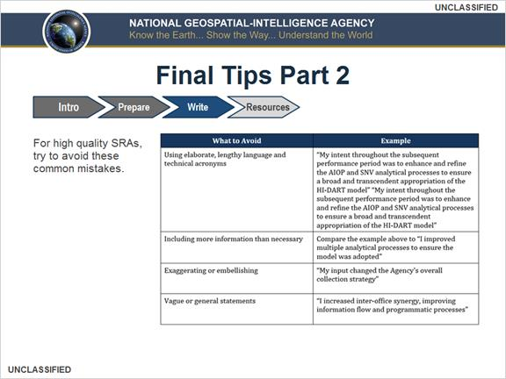

3.16 Last Steps
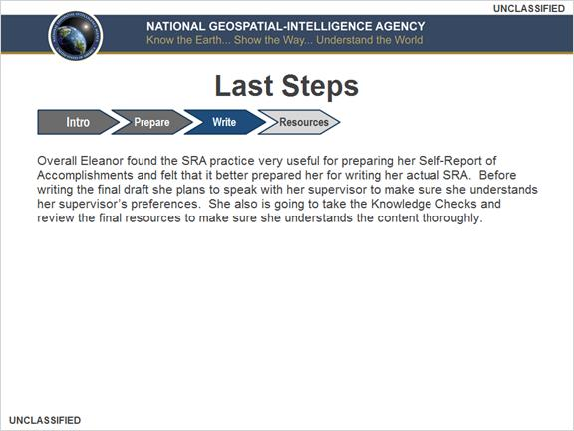

4. Resources

4.1 Why should you write a Self-Report of Accomplishments? Select what does not apply.
(Multiple Choice, 10 points, 1 attempt permitted)
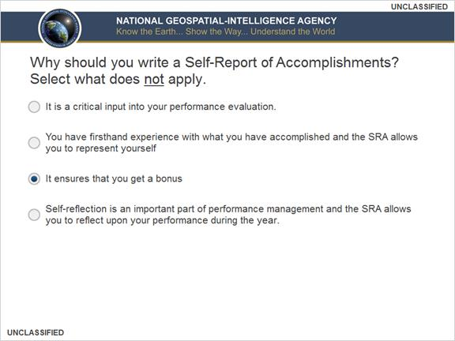
Correct | Choice
 | It is a critical input into your performance evaluation.
 | You have firsthand experience with what you have accomplished and the SRA allows you to represent yourself
X | It ensures that you get a bonus
 | Self-reflection is an important part of performance management and the SRA allows you to reflect upon your performance during the year.

Feedback when correct:
That's right!

Your Self-Report of Accomplishments does not guarantee a bonus. It does, however, give you the opportunity to provide your Rater and Reviewer with detailed information that will be helpful to them in their evaluations of you. A well-written and effective SRA can be your best means to make an argument for a performance-based bonus.
Feedback when incorrect:
You did not select the correct response.

Your Self-Report of Accomplishments does not guarantee a bonus. It does, however, give you the opportunity to provide your Rater and Reviewer with detailed information that will be helpful to them in their evaluations of you. A well-written and effective SRA can be your best means to make an argument for a performance-based bonus.

Correct (Slide Layer)
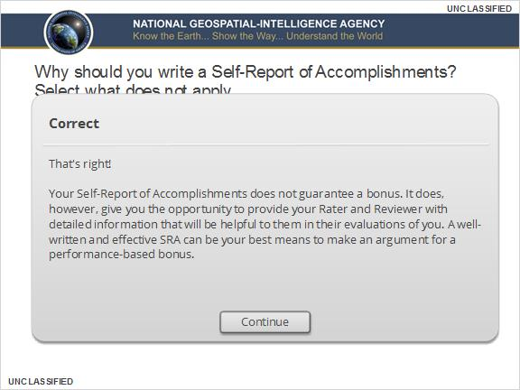

Incorrect (Slide Layer)
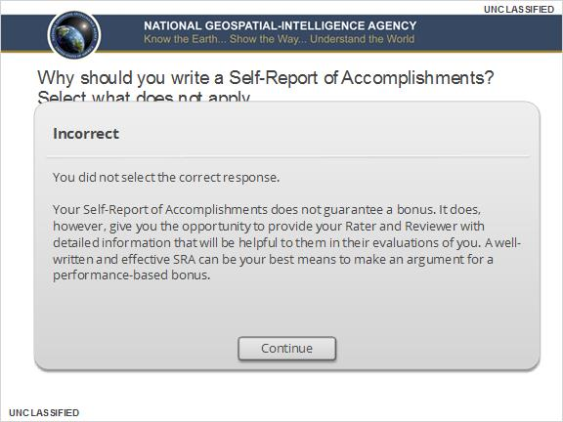

4.2 What narratives that your supervisor will write does your SRA directly support? Select all that apply.
(Multiple Response, 10 points, 1 attempt permitted)
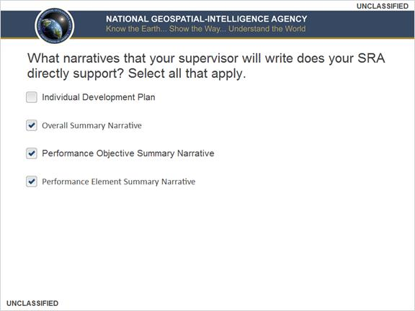
Correct | Choice
 | Individual Development Plan
X | Overall Summary Narrative
X | Performance Objective Summary Narrative
X | Performance Element Summary Narrative

Feedback when correct:
That's right!
You need to base your SRA on specific accomplishments toward assigned performance objectives and the elements.
Feedback when incorrect:
You did not select the correct response.

You need to base your SRA on specific accomplishments toward assigned performance objectives and the elements.

Correct (Slide Layer)
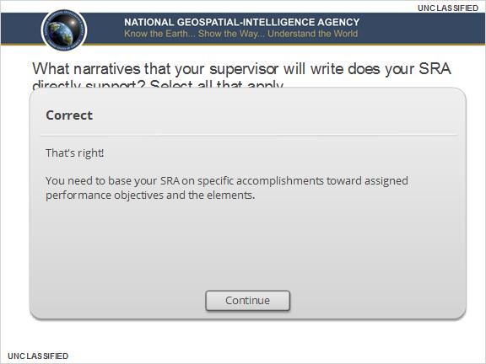

Incorrect (Slide Layer)
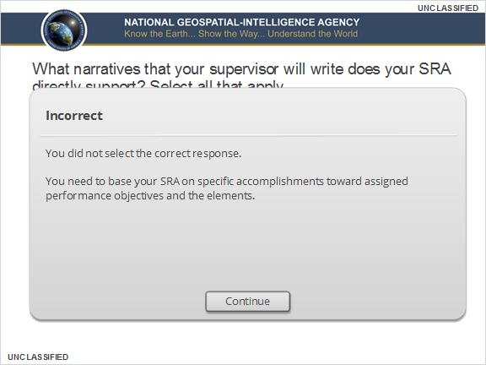

4.3 Which documents or materials should you have with you to write your SRA? Select all that apply.
(Multiple Response, 10 points, 1 attempt permitted)
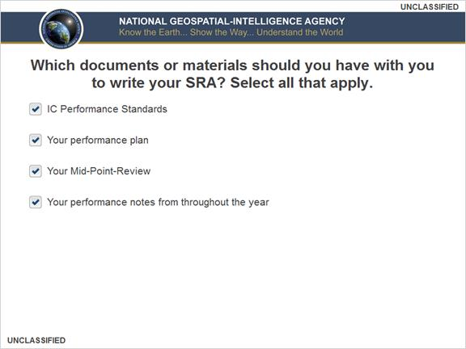
Correct | Choice
X | IC Performance Standards
X | Your performance plan
X | Your Mid-Point-Review
X | Your performance notes from throughout the year

Feedback when correct:
That's right!

You should also consider including additional materials including validated customer feedback, your organization’s goals and priorities, and any information your supervisor may have provided you about writing your SRA.
Feedback when incorrect:
You did not select the correct response.

You should also consider including additional materials including validated customer feedback, your organization’s goals and priorities, and any information your supervisor may have provided you about writing your SRA.

Correct (Slide Layer)
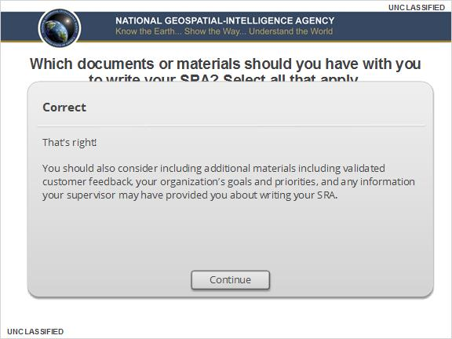

Incorrect (Slide Layer)
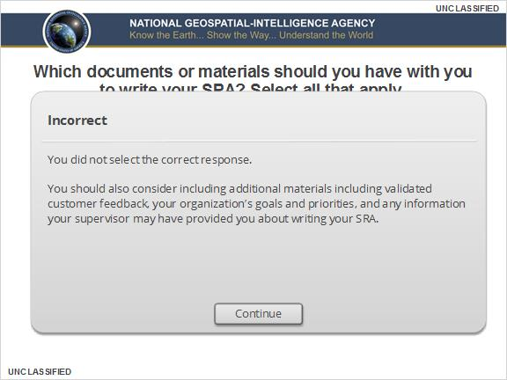

4.4 With what do your accomplishments need to align? Select all that apply.
(Multiple Choice, 10 points, 1 attempt permitted)
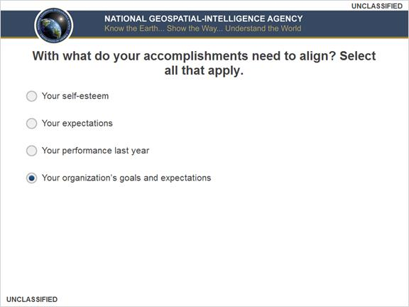
Correct | Choice
 | Your self-esteem
 | Your expectations
 | Your performance last year
X | Your organization’s goals and expectations

Feedback when correct:
That's right!
You should be in regular communication with your supervisor to remain aware of organizational priorities, in case those priorities change. All accomplishments should correspond back to your KC and Agency.
Feedback when incorrect:
You did not select the correct response.
You should be in regular communication with your supervisor to remain aware of organizational priorities, in case those priorities change. All accomplishments should correspond back to your KC and Agency.

Correct (Slide Layer)
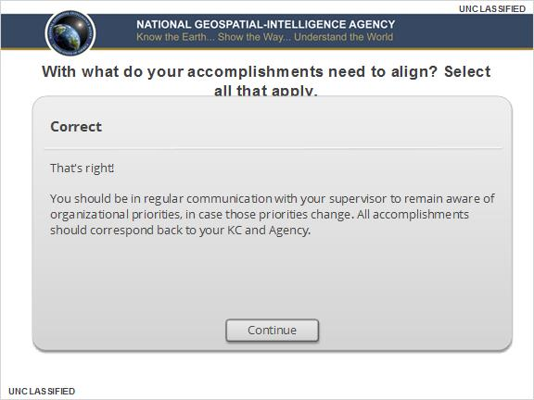

Incorrect (Slide Layer)
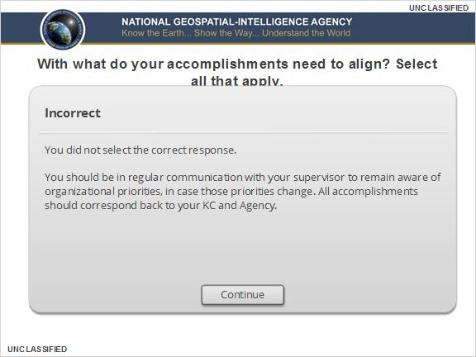

4.5 After outlining your accomplishments, you began to write your SRA, covering: your understanding of the Objective, each measure and target, and an evaluation of your strengths and weaknesses. What is missing?
(Multiple Choice, 10 points, 1 attempt permitted)
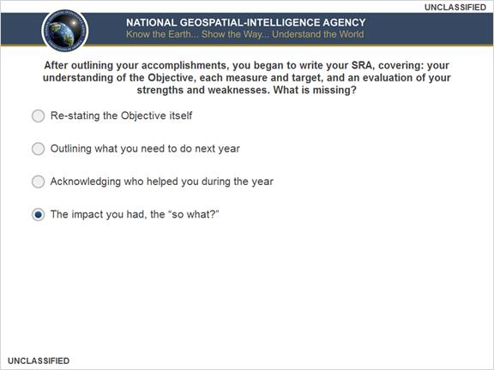
Correct | Choice
 | Re-stating the Objective itself
 | Outlining what you need to do next year
 | Acknowledging who helped you during the year
X | The impact you had, the “so what?”

Feedback when correct:
That's right!
This is the most important part of the narrative. If you are hoping for a final rating above the successful “3,” you should clearly convey the contribution you had and how the contribution links to organizational priorities.
Feedback when incorrect:
You did not select the correct response.
This is the most important part of the narrative. If you are hoping for a final rating above the successful “3,” you should clearly convey the contribution you had and how the contribution links to organizational priorities.

Correct (Slide Layer)
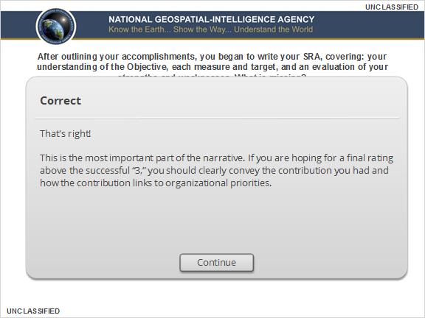

Incorrect (Slide Layer)
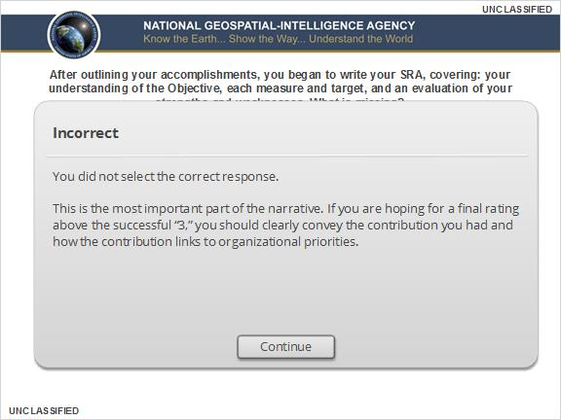

4.6 Select all the options that complete the following statement: When writing your SRA do not ____.
(Multiple Response, 10 points, 1 attempt permitted)
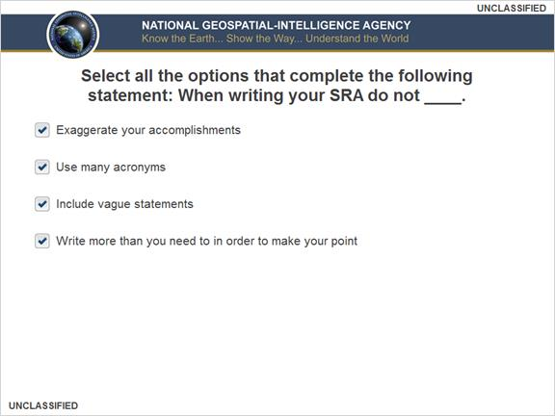
Correct | Choice
X | Exaggerate your accomplishments
X | Use many acronyms
X | Include vague statements
X | Write more than you need to in order to make your point

Feedback when correct:
That's right!
Following all of the above will help you write a more effective and honest assessment of your contributions to the Agency.
Feedback when incorrect:
You did not select the correct response.
Following all of the above will help you write a more effective and honest assessment of your contributions to the Agency.

Correct (Slide Layer)
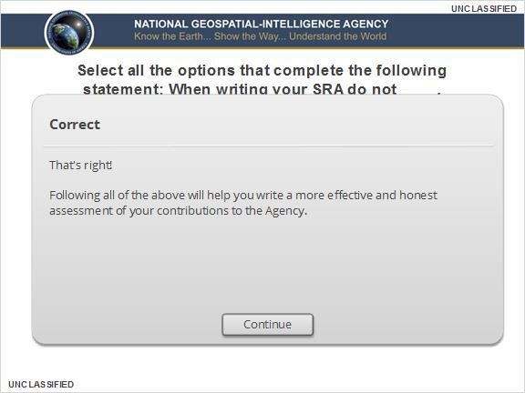

Incorrect (Slide Layer)
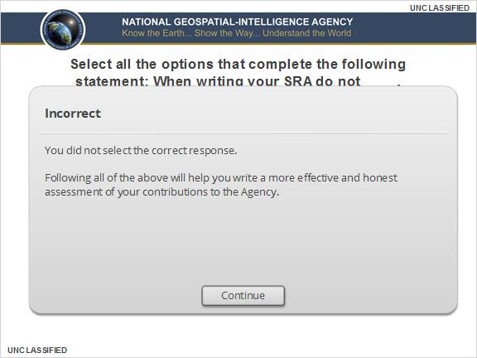

4.7 Complete the sentence. Performance Elements indicate ____ you accomplished your Objective.
(Multiple Choice, 10 points, 1 attempt permitted)
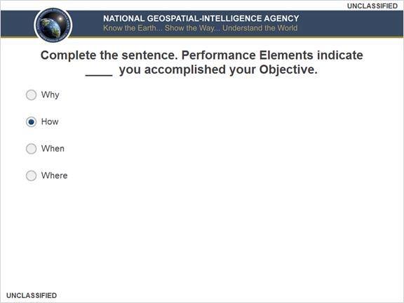
Correct | Choice
 | Why
X | How
 | When
 | Where

Feedback when correct:
That's right!
The Performance Elements refer back to behavioral descriptors for your performance category that can be found in the IC Performance Standards.
Feedback when incorrect:
You did not select the correct response.
The Performance Elements refer back to behavioral descriptors for your performance category that can be found in the IC Performance Standards.

Correct (Slide Layer)
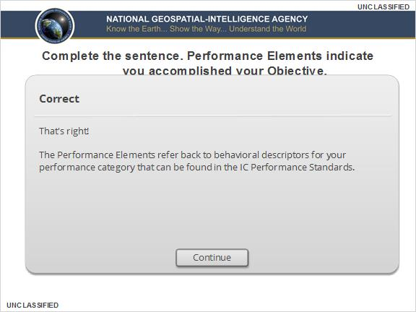

Incorrect (Slide Layer)
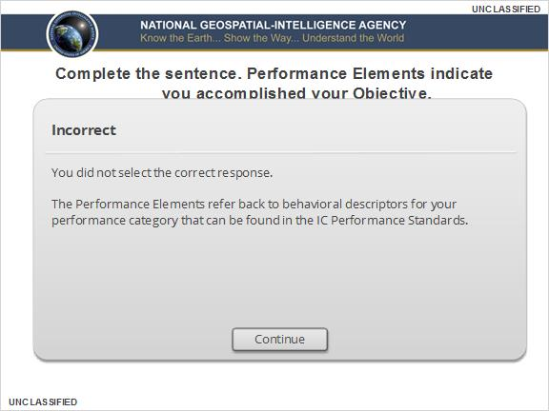

4.8 What if I need additional SRA practice?
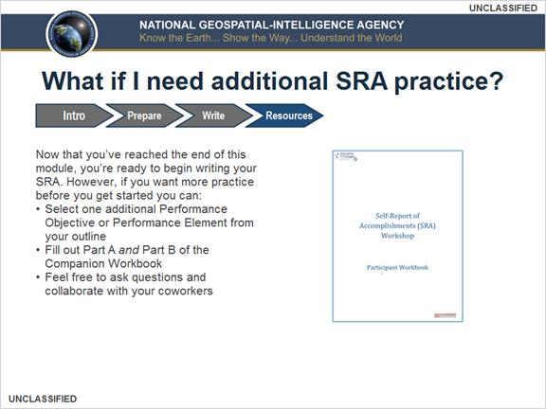

4.9 Where can I find additional resources?
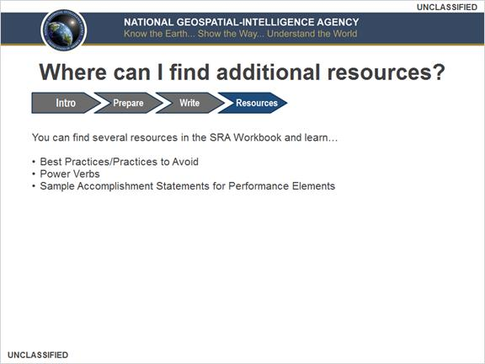

4.10 When Should I Start the SRA Process?
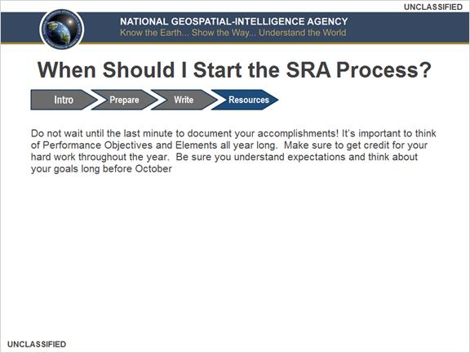

4.11 More Information and How to Contact Us
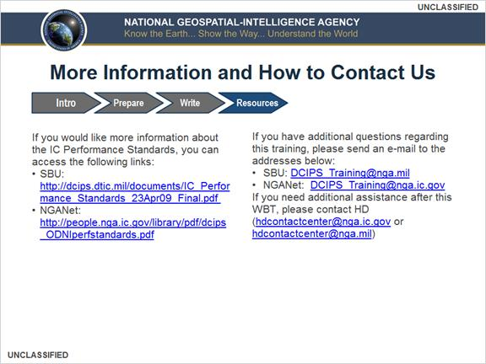

4.12 Untitled Slide


